Jalen Powell

8/1/2023

COMP 5120

Homework 4

**Question 1:** Suppose that a page can contain at most four data values and that all data values are integers. Using only B+ trees of order 2, give examples of each of the following:

1. A B+ tree whose height changes from 2 to 3 when the value 25 is inserted.  
   Show your structure before and after the insertion.

* 
* Before
* 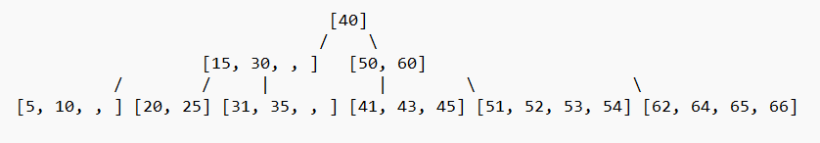
* After

1. A B+ tree in which the deletion of the value 30 leads to a redistribution. Show  
   your structure before and after the deletion.
2. A B+ tree in which the deletion of the value 35 causes a merging of two nodes  
   but without altering the height of the tree.

**Question 2:** Answer the following questions about Linear Hashing:

1. How does Linear Hashing provide an average-case search cost of only slightly  
   more than one disk I/O, given that overflow buckets are part of its data  
   structure?

* Linear Hashing uses a dynamic hash table with a split and merge algorithm that helps distribute data more evenly. This reduces the likelihood of collisions and the need for overflow buckets.

1. Does Linear Hashing guarantee at most one disk access to retrieve a record  
   with a given key value?

* Linear Hashing does not guarantee at most one disk access to retrieve a record with a given key value, but it provides an average-case search cost of slightly more than one disk I/O. The actual number of disk accesses depends on the data distribution and the hash function used.